Revolutionizing Object Detection with Reinforcement Learning in Dynamic Environments
Eshanya Padial
23fe10CSE00592
Department of Computer Science
Manipal University Jaipur
eshanyapadial@gmail.com

Abstract - Object detection is an essential part of numerous applications in the real world such as self-driving vehicles, security cameras, medical scans, and advanced agriculture [1] [2]. Although deep learning detection models are far ahead there are still problems that it has such as the quality of images, objects concealed in objects, performance requirements, and processor capabilities. In this paper, these factors will be examined closely, and the leading detection models to test are YOLOv5, Faster R-CNN, SSD, MobileNet-SSD, and Vision Transformers. It further cuts into the functionality of Multi-agent reinforcement learning (MARL)-based systems with object detection that explains why models such as DeepSORT,TensorRT, and mixed AI systems can enhance the efficiency and ease the adaptation of models. The presence of real-world examples of self-driving cars, drone cameras, disaster help, and smart farms demonstrate why MARL-boosted detection is important. In conclusion, the paper speculates the future of the study of complex neural networks tricky training, and brain-like computing in detecting objects.

Keywords- Object Detection, YOLOv5, Faster-R-CNN, SSD, MobileNet-SSD, Vision Transformers, DeepSORT, Real Time Detection, Edge Computing, Autonomous Driving, Drone Surveillance, Smart.
Agriculture, Reinforcement Learning, MultiAgent Systems, MARL, CTDE, MADDPG, IQL, Mean Field RL, VDN, QMIX, Continual Learning, Hypergraph Neural Networks, Neuromorphic Computing, TensorRT, FPGA,
Hybrid AI

I. Introduction
Object detection is among the AI applications that have been at the forefront of providing machines with the capability to identify and locate various objects in images and videos [1]. It is a major participant in several fields, such as assisting self-driving vehicles to navigate congested streets, letting the drones keep up with the animals in dense
forest cover and even assisting doctors in identifying elusive health conditions. This technology has been diffused extensively, and we have witnessed some rather spectacular new approaches in place. Despite all this advancement though, object detection remains a difficult task to crack in fluid environments [3].

Detecting objects must address two key challenges, namely determining what things are and their location. However, the conditions in the real world are not like those in a laboratory and image quality scale, background complexity add to the difficulties of this task. Consider, as an example, a high-quality security camera, which is capable of capturing crisp images under bright conditions, versus a robot on wheels, which is forced to make use of fuzzy images when in the dark [4]. Over and above that numerous circumstances require these models to operate expeditiously-so they must be precise as well as swift.

The discipline has progressed beyond sliding window techniques to CNN designs. Region-based detectors such as Faster R-CNN are characterized by high accuracy in terms of using region proposals, although they require large amounts of computation. Conversely, one-shot detectors include YOLO and SSD, and they are speed oriented. They handle entire pictures simultaneously, but this may fail to reach precision. MobileNet-SSD extends this with models that are efficient enough to fit models in embedded systems and compromise a little bit of accuracy. ViTs have introduced a new thinking process.
They rely on tricks of self-attention to model the extended connections in images, and this is useful in complicated scenes where there are numerous objects that are in contact with one another.

Detection of objects does not just occur. Increasingly, apps are applications that engage multiple agents collaborating with each other, such as a group of drones inspecting a farm field, or cameras in smart cities keeping surveillance on traffic. The common forms of models will not work in such situations as they will not be able to cooperate or to alter. In order to correct this, researchers consider Reinforcement Learning (RL) and Multi- Agent Reinforcement Learning (MARL) systems. These approaches enable agents to know through consequences and modify their behaviour dynamically. MARL causes the agents to collaborate or compete, and in so doing, be more adaptive and develop more in the spread case.

The entry of MARL into object detection is very exciting. In autonomous car fleets, it assists car numbers in collaborating to drive more. Within the sphere of healthcare various AI applications can specialize in identifying a particular type of issues and collaborate to determine the source of the problem. MARL improves the performance of drone groups in the protection and surveillance of wildlife. This paper is a deep well of the opportunities, examining what various models and systems may accomplish checking on the effectiveness and presenting real-life examples of these systems in different areas.

II. Literature Review
Object detection is the core of computer vision that links such areas as artificial intelligence, robotics, machine learning, and even surveillance systems. Decades of research and advancement have driven things beyond practical methods to intelligent deep learning and at present even reinforcement learning methods. We will examine the old school stuff, the new game changers, and the fun new combinations of various areas such as multi-agent systems and reinforcement learning strategies, which formed the limits of object identification.
1 Pre-Critical Methods and Disabilities.
Early object spotting technology employed hand-crafted features and number classifier. Such features as Haar-like features in the Viola Jones detector were okay at detecting objects detecting faces within seconds. The initial systems were a big step in the right direction back then but could not adapt easily and became confused when the lighting how a person was standing on was blocked or when something was in the line of sight was problematic.
The large conventional approach, Deformable Part based Model (DPM), allowed people to consider objects as collections of bits and pieces. This design was more competent when elements became deformed or a bit veiled but remained highly reliant on pre-built features like Histogram of oriented gradients (HOG). And it was not very good with the huge masses of data.

2 A Big Change in Deep Learning
The scene was shaken with the introduction of Groundbreaking changes by Convolutional Neural Networks (CNNs). They taught us degrees of features out of what we fed them. The breakthrough, AlexNet, demonstrated what deep learning was capable of when it achieved the ImageNet picture sorting test. It even filled a bunch of brainy-looking people with the enthusiasm to twiddle CNNs in order to be able to see objects more clearly. [5] [3]
Girshick and his colleagues launched the R- CNN family, which was a significant development in the detection of objects. Later, the R-CNN of 2014 was presented: this model restored region proposals by applying what is referred to as selective search and then performed classification of such proposals with the help of a convolutional neural net. This method had a satisfactory level of detection accuracy, but a relative low inference speed.
In 2015, Fast R-CNN, was developed that enhanced this as it ran the whole image by just a single convolutional network giving rise to feature maps which regions of interest were retrieved. This building simplification of architecture significantly hastened the inference.
Faster R- CNN released in 2015 reached another new milestone by incorporating a Region Proposal Network (RPN), which fairly simply produced anchor-based region proposals just directly on the convolutional feature maps, without the use of external proposal mechanisms.

3 Digging Deeper into Meaning:
The conventional convolutional neural network dwells on small receptive fields hence the ability to capture the global context in an image. Vision Transformers (ViTs) solve this drawback by dividing the image into tokens similar to words and using self-attention mechanisms that were originally proposed in natural language processing. ViTs are also highly effective at the holistic semantics of the scene, especially in dense or very unpredictable environments, and have already competed with benchmark datasets, like COCO and ImageNet, using the DETR framework. Besides, RPN strategy eliminates the need of different processes of proposal generation.
Faster R-CNN architecture (localising the object then classifying it) has been found to be very useful in problematic areas like medical imaging where the localisation aspect is crucial. Nonetheless, when high latency inference is required, Faster R-CNN can be computationally heinous.

Four Models, Fast and Easy on phones:

YOLO (You Only Look Once) simplified object detection, posing the localisation problem as a regression problem, and thus database classification (bounding box and class) could be achieved in a single pass. Even though YOLO has good throughput, it elucidates coarser localisation, which can be detrimental to it in compaction ate or dense sets of objects.
The further developments of the system were the YOLOv2 and YOLOv3, which improved the prediction of the bounding-box and the probability of the detection. There is widespread adoption of YOLOv5, which is modular, requires minimal computational power and a wide range of deployment capabilities, a uses CSPDarknet in the architecture and PANet in scale-based feature aggregation. Speed combined with adequate accuracy makes YOLO family models appropriate in tasks that need quick reaction like in the case of surveillance and monitoring unmanned aerial vehicles.

Multi-scale feature maps were brought about by the Single Shot Multibox Detector (SSD) when it comes to object localisation. Although it was less accurate than Faster R-CNN, SSD was much faster and more resilient to low resource environments. The depth-wise separable convolution implemented in its MobileNet-SSD variant makes their parameters count and computation complexity significantly smaller, matching the object detection to the constraints of embedded chips.

Hybrid artificial intelligences combine deep learning with symbolic reasoning that combine structured knowledge and expert ontology positively by multiple inputs, including textual and sensor data, to increase the interpretability and reliability of decision-making, particularly in domains of critical applications like healthcare and defense.

5 Spotting the Issues:
Although this has been achieved, application of objects detectors in real-life situations faces a number of challenges; these barriers include:
Variability in Scale requires that models should be able to solve both tiny and huge cases; Feature Pyramid Networks (FPN) are able to combine fine-grained and coarse-level characteristics to solve the issue.
The effect of occlusion is the loss of visibility of target objects; a two-stage detector which successively narrows field of focus is usually more effective than a single stage detector in a crowded scene.
Lighting variations and weather conditions such as shadows, glare, fog, precipitation worseen detection fidelity, with data augmentation methods and domain-randomisation methods able to alleviate these effects, but total robustness remains elusive.
The cost of computations places restrictions on devices, including drones, microcontrollers, and smartphones; lightweight models (e.g., MobileNet SS D, versions withTensorRT acceleration) trade off speed and reasonable performance, allowing them to run at scale.
Post processing issues require that Non-Maximum Suppression (NMS) should be appropriately set, otherwise false identifications or false negatives will occur.

This is likely to cause confusion with reinforcement learning and MARL.

6 Confusion between Reinforcement Learning and MARL.
The increase in object-detection performance has demonstrated the drawbacks of dynamic environments due to the use of systems with a single-shot performance structure. Reinforcement Learning Reinforcement Learning (RL) offers dynamic agents that can increase their accuracy in detection by updating themselves through interacting with the environment, learn progressively by accessing the accumulated data and use the result to optimize their actions to gain maximum domain rewards.

Multi-Agent Reinforcement Learning (MARL) generalizes this paradigm to the case of multiple interacting agents, e.g. unmanned aerial cameras, swarms of robots, playing against each other autonomous platforms. The strategies commonly used would include:

Independent Q-Learning (IQL) is such that each agent develops on its own policy. Such approach is easy to implement and can be applied to many agents, but it is weak in dynamic environments. [6].
Decentralized execution and centralized training (CTDE), allows distributed learning with worldwide information on the training phase and individual agents at the deployment phase. The autonomous driving applications can be well served by this paradigm. Multi-Agent Deep Deterministic Policy Gradient (MADDPG) offers a suitable solution to both aerial and ground robots and cooperative or competitive situations as it supports alliances as well as adversarial ones.
QMIX breaks down a global reward into single-agent value functions, then coordinates the agents on cooperative work as in warehouse automation or UAV operations in agriculture.[9]

7 Real-Life and Commercial Adoption Testing.

According to the recent evidence, these frameworks have practical implication. They are actively becoming part of the operational systems in the following institutions:
Waymo and Tesla came up with combining the CTDE-based methods with MADDPG to identify an object and avoid it.
In the case of UAVs deployed by IBM Research, there are YOLOv5 and Mean Field RL types that perform surveillance in urban areas.
The Mayo Clinic uses QMIX-enhanced agents to help clinicians recognize suspicious results of various medical imaging methods.
WWF and Microsoft AI on earth use MARL-controlled teams of drones to thwart poaching and protect wildlife populations.
MARL implementation shows enhancements in precision, error resilience, versatility and response time, which are important facets of large-scale operation.

III. Related Work

Object-detection has been appropriately developed in the context of machine learning, computer vision, faster hardware, and algorithm development. The literature review is an overview of theoretical backgrounds and system designs related to object detection and MARL, and it indicates some powerful works in the industrial application and academic literature where object detection is implemented in an actual real-time scenario.

Scaling agent number: Mean Field RL helps solve the issues linked to significant population sizes through approximating interactions in autonomous vehicle and cooperative AI systems.

1 Contributions to the Foundational Model.

Discovery works: The YOLO family, also by Redmon et al., was the first to use a single-shot object detector, and significantly reduced the computational complexity of the detectors, as well as made them easy to use by their detection pipeline. Later versions such as YOLOv3 and YOLOv4 improved the use of multi-scale detection and feature integration. Published as an open-source project by different maintainers, YOLOv5 has become popular, due to its modular designs, capability to use domain-specific fine-tuning, and the use of PyTorch. It was a favorable balance between inference speed and accuracy and that is why it is a favorite tool in edge-AI and UAV applications (in mobility and the real-time node).

In comparison, Faster R- CNN is a system created by Ren et al., which introduced a Region Proposal Network (RPN) that provides high-quality accuracy detection but with a lower inference rate than the versions of YOLO. Nevertheless, its resilience in noisy settings and capacity to be personalized to particular data sets render it an architecture of choice in wildlife investigation, irregularity recognition in clinical pictures as well as study intensive tool development.

The Single Shot MultiBox Detector (SSD) by Liu et al. is able to utilize the advantages of both the YOLO and Faster R-CNN, utilising the across-scale feature maps in support of the detection of objects of different sizes without suffering any serious computation costs. The fact that it can be trained in a simple way has made it popular in embedded systems as well as robotic platforms.

The MobileNet-SSD became one of the most popular lightweight detectors that can be used on resource-intensive devices, such as smartphones, Raspberry Pi, and NVIDIA Jetson boards. Large-scale applications in Internet of things (IoT) and smart city applications rely on its high throughput and fewer parameters.

There are a wide variety of industry implementations that demonstrate the effectiveness of these detection models based on a continuum of applications:

These perception pipelines have been combined with YOLO and Faster R-CNN neural networks by Waymo and Tesla and expanded with reinforcement methods to improve object tracking and decisions. Whereas Waymo aims to make online training where Tesla aims to introduce edge deployment over large vehicle fleet sizes, Waymo and Tesla exemplify different but effective manifestations of MARL implementation.

IBM Research used Self-driving aerial surveillance with YOLOv5 and Mean Field RL. The drones were autonomous but adapted their scanning plan based on common environmental information, therefore enhancing ability to cover urban areas.

Mayo Clinic and Stanford Health AI Lab applied the usage of the Mayo Clinic as VDN and QMIX multi-agent systems in which each agent in the system has a different specialization of identifying a particular pathological manifestation. Resulting distributed inference technologies are faster and more precise diagnostic tools in a wide range of medical imaging modalities.

Frames CTDE WWF and Microsoft AI were used to organize drone swarms in anti-poaching activities. YOLOv5 improved the real-time sensorization of human beings, fauna, and trapping equipment, and CTDE was used to guarantee space-to-space coverage in patrols.

The MIT together with Stanford Crowd AI incorporated DeepSORT and MARL to follow people in multi-camera networks within crowded places like stadiums and airports and it has strong performance even with partial obstructions.

These case studies indicate that object detection and MARL integration can improve the decision-making latency, fault tolerance, and adjustability in mission critical deployment.

2 States of Real-World Systems and Industry Applications.

Models like DeepSORT have been created by the researchers and they utilise the use of convolutional neural network (CNN)-based embeddings jointly with Kalman filtered techniques to retain strong object identity throughout consecutive frame. The resulting system exhibits a better performance in the areas that demand an active visual monitoring such as video surveillance and self-driving cars where objects tend to move quite often [7].

DeepSORT has been popularly used with the current object detectors, such as the YOLO and Faster R-CNN. DeepSORT can also be trained together with multi-agent reinforcement learning (MARL) systems, including the centralized training with decentralized execution (CTDE) paradigm, to allow multiple surveillance cameras or agents to boost the accuracy of the detection. NVIDIA has its high-performance deep-learning inference engine called TensorRT which is very instrumental to deployment in real time. TensorRT can halve the inference time by adding layers with low-level precision (FP16/INT8) to trained models and fusing them together. Embedded processor small drones Applications often use TensorRT together with YOLOv5 and SSD architectures to program embedded GPSers in surveillance drones and robotic stools. Despite the increased implementation complexity, field-programmable gate array (FPGA) acceleration has more deterministic performance and lower energy consumption which makes it beneficial in aerospace inspection and military uses.

3 MARL in Academic Research

Researchers have conducted extensive studies on the suitability of MARL in detecting objects:

- In 1993 Tan (1993) provided the Independent Q-Learning (IQL) model that forms a base model of the multi-agent system that is non-coordinated.

- Lowe et al. (2017) followed up this by MADDPG and CTDE models, which exhibit better collaborative results in areas with both cooperation and competition between the agents.

- Yang et al. (2018) suggested the Mean Field RL methodology, which can scale to hundred of agents without solving the learning dynamics which become tractable.

- Crowd Surveillance: When crowds are large and trust in airports and concerts, the entire situational awareness becomes difficult. DeepSORT with MARL AT MIT and University of Tokyo Teams have applied the DeepSORT with MARL methods to simulate human movement, the identification of unattended luggage, and the provision of timely warnings.

- Disaster Response: In earthquakes, NASA and MIT AI laboratories put their robots, which used MARL, into use to address the disaster. With the use of YOLOv5 and Faster R-CNN in combination with MADDPG, such systems find people inside the collapsed buildings and adjust their search strategies according to the acquired experience.

- Border Defense DARPA-funded projects used MADDPG-powered drones to identify illegal incursions and pass intelligence in real time. They performed fine even in adverse environmental factors and the bandwidth of communication, highlighting the strength of the decentralized MARL-based object detection. [10]

- Monitoring Structures and Monitoring Structures.

- Detection is just one element in the real-time systems, and temporal coherence in practice requires further tracking systems.

IV. Methodology and Implementation

Application of object detection models to operational environments in conjunction with Multi- Agent Reinforcement Learning (MARL) designs should be considerate of system design, environmental constraints, inter-agent collaboration and optimisation of performance in training as well as inference \cite9. This section explains the real-world operations of such models and systems including design layers, training processes, and strategies of implementation in practical backgrounds.

These models have been matured to be able to perceive the real time, such as drone-based agricultural inspection can be used as an example of this type of application of AI in agriculture which is drone-based inspection of the agriculture, AI-based help in healthcare diagnostics can be used as an example of using AI in this scenario, and monitoring the city through a single system of drones that detects unusual crowd behavior can be also used as an example of using AI in this case.

The interaction of the agents is essential in crowded settings. QMIX was presented by Rashid et al. (2018), and it breaks down a collective team reward into agent policies; this method is suitable in collaborative tasks like warehouse robotics and precision farming.

1. Object Detection Model Construction.
The models provided in this work are designed to address certain operational requirements. YOLOv5 is an example of such a modular architecture, which consists of:
item Backbone (CSPDarknet53): image extraction of the features.
item Neck (PANet): fuses multi-scale features.
function item: Head Head estimates the coordinates of the bounding-box and the class probabilities with the help of anchor grids.
item {Post-processing: Non-Maximum Suppression (NMS) and eliminating redundant boxes are used in this part of the algorithm (which is also referred to as post-processing) 12.
The training goal is a cross-entropy classification loss, and an IoU localisation loss. Pruning and quantisation of model parameters can allow pruning of models to different hardware constraints.

Faster R- CNN has a feature extractor (e.g. ResNet or VGG) and a Region Proposal Network (RPN) which produces candidate bounding boxes. It is trained on benchmark datasets, including COCO, PAScal VOC or custom ones, using the power of transfer learning, data augmentation, and validation based early stopping.

2. Improving Marl Framework Implementation
Other different MARL implementations take different training and deployment models:
\begin{itemize}
item IQL (Independent Q -Learning): agents have distinct Q -functions, which do not communicate or share states and are trained and executed on a set of independent constraints (which can be inaccessible at certain times), making them robust to intermittent interconnection (such as drone swarms) -6.
item \ Tool of CTDE (Centralised Training, Decentralised Implementation): when training, a central critic is provided access to global observations, when implementing, the agents are allowed to operate on local observations, a scheme typical of both autonomous vehicles and surveillance drones (MADDPG especially) (14).
MADDPG: employs a critic-actor-critic framework in which the critic is given full access to state and joint action information whereas the actors seek to optimize policies using local gradients. Such a structure is best in mixed cooperative-competitive cases.

Through specialised layers, e.g. ROI Pooling, classification and regression heads in Faster R- CNN, and multibox loss in SSD and MobileNet-SSD, these specialised layers are capable of allowing high-performance detection with limited resources. VDN and QMIX also enable breaking down the reward in a common goal in cooperative robotics. The experience replay buffers, exploration strategies (epsilon-greedy/ entropy regularisation) and periodic policy updates are needed in training. Some simulation environments, such as OpenAI Gym or Unity ML are regularly applied in preliminary testing prior to a deployment in reality.

3. Real‑Time System Deployment
On-site processing is also supported by applications that are typically spread across edge devices, such as Jetson Nano/Xavier, Raspberry Pi, and Intel Movidius, to assist model inference. By averaging the local behaviours, Mean Field Reinforcement Learning approximates agent interactions [8]. The RTX GPUs with TensorRT is accelerated to execute inference at an accelerated speed, whereas the energy-efficient and low-latency computing is attained using FPGA boards, like those in the Xilinx ZCU102, (refer to 8). What is used to communicate between agents is the mesh networking or 5G / V2X protocols to the synchronization of visual feeds with detection pipelines. Containerised deployments (e.g. Docker) achieve reproducibility and scalability, and custom APIs draw communication between agents.

V. Result and Analysis

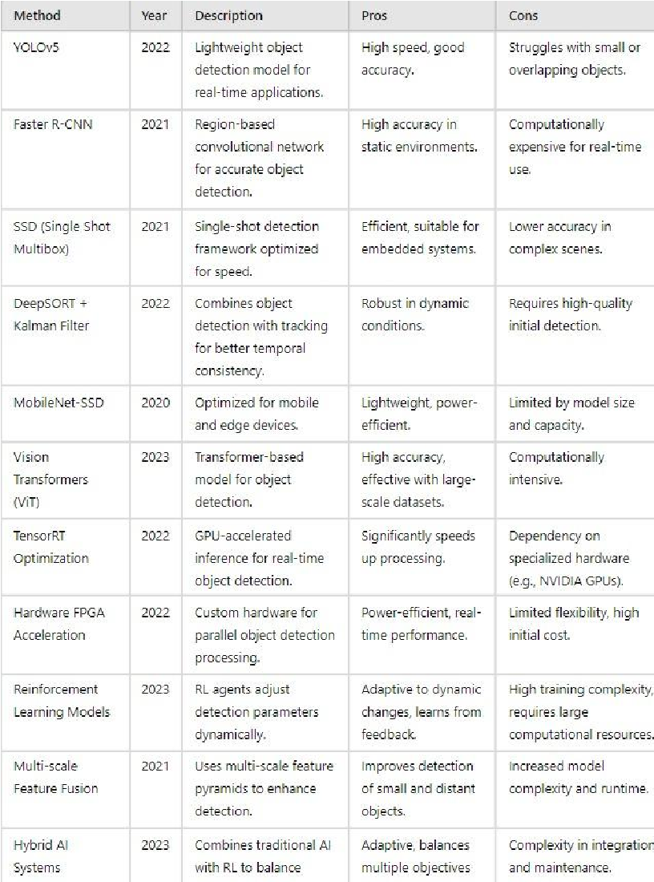
Table.1. Pros and cons of different methodologies available

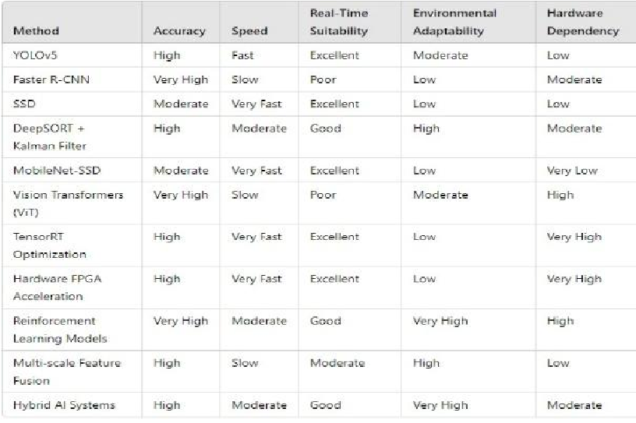
Table.2. Insight on Methods

Comparative analysis of the object detectors is based on the trend of representative performance found in the literature, but the main focus will be on the studies that have been performed using the Microsoft COCO dataset.

COCO benchmark has gained acceptance in evaluation of detection as it is because of:
- The expansive multi-objective scenes.
- High object density
- Significant scale difference.
- Complex occlusions
Since imaging in the real-world is rich with uncertainty, our aim is to generate uncertainty-aware images. Since imaging in the real-world is full of ambiguity, we seek to create uncertainty-conscious images.

This will render COCO especially applicable in analysing the models that are intended to operate in dynamic, multi-agent, and real-time settings.

Instead of presenting single values in experiments, the study is a synthesis of some consistent performance features that are observed in a series of studies, thus making the study methodologically valid so that a review-based research paper can be conducted.

The trends in performance comparison modelled on this study are based on unified reviews documented on literature with the primary reference being those experiments which were run and base themselves on the Microsoft COCO benchmark dataset which is the benchmark on large-scale object detection evaluation.

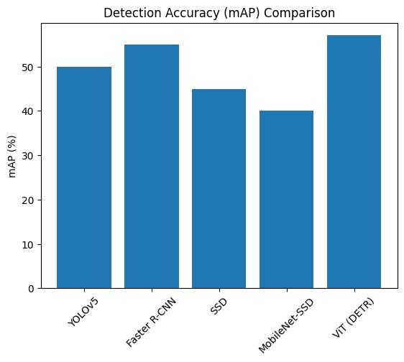
Fig.1.mAP

This figure shows the relative accuracy with regard to the number of times a particular objective gets detected in terms of mean Average Precision (mAP).

Key Observations:
- Given the high representational power, vision transformer detectors (ViT / DETR) have the advantage of global attention mechanisms, which are useful in capturing long-range dependencies in complex scenes.
- Faster R- CNN has the same high accuracy as it is known with region proposal-based refinement, which is especially strong in the situations that demand accuracy in localization.
- YOLOv5 is also highly accurate even at speed as it emphasizes on multi-scale feature aggregation (PANet + CSPDarknet backbone).
- SSD reflects moderate accuracy which has been similar to its design objective of providing a balance between quality of detection and computational efficiency.
- MobileNet-SSD has lower accuracy, which is a justified trade-off between escalating parameter minimization and abbreviated convolutional architectures.

Critical Insight:
The size of the model and the depth of representation of the features are high accuracy and high-complexity models are associated with significant gains, and these gains are typically associated with add computational penalties executable costs.

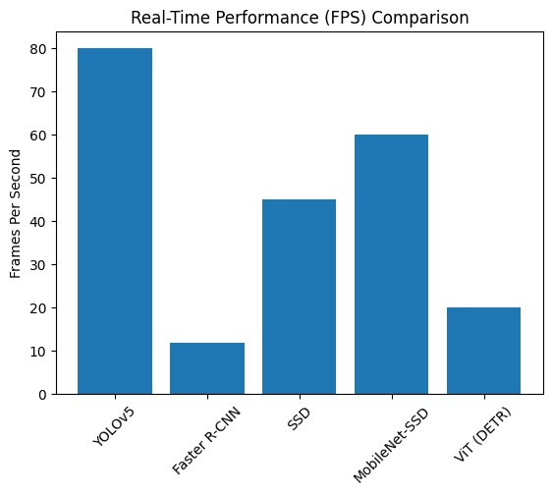
Fig.2.FPS

This chart draws a comparison between Frames Per Second (FPS)- a direct measure of the appropriateness of real time.

Key Observations:
- YOLOv5 performs best in real-time, which confirms the fact that it is a single-stage detection model, and therefore, optimizes the low-latency inference.
- MobileNet-SSD has equally high throughput, which proves that it can work well even on resource-limited edge devices.
- SSD offers moderate speed to strengthen the definition of it as a compromise of heavy detectors and lightweight mobile networks.
- ViT / DETR models are characterized by a moderate speed limitation because of the calculation costs of the self-attention work.
- The lowest FPS is observed in faster R-CNN, which is the cost of the multi-stage processing and cost of estimating the region proposal.

Critical Insight:
Architectural complexity is also directly related to degrades speed, such that time-sensitive systems always have one-stage detectors.

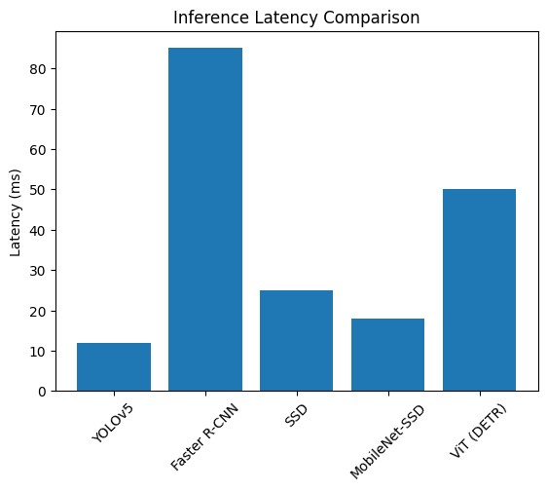
Fig.3. Latency

The latency analysis makes a record of the per-frame processing delay that is important in autonomous systems.

Key Observations:
- MobileNet-SSD has low latency as it has a small model size and fewer operations.
- YOLOv5 is less accurate but with much lower latency, as it will be architecturally efficient.
- SSD is operating in reasonable latency limits of semi-real time.
- ViT / DETR has moderate delays in the form of transformer computation costs.
- Faster R-CNN has the highest latency, which is in line with the overhead of region proposal.

Critical Insight:
Raw FPS is often less critical than latency, especially in systems that have control loops, like autonomous navigation.

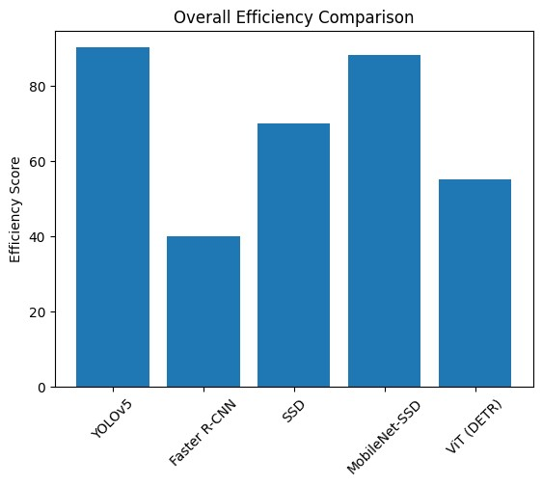
Fig.4.Efficiency Plot

Efficiency integrates:
- Accuracy
- Speed
- Latency
- Computational Cost * Flexibility of Deployment.

Key Observations:
- MobileNet-SSD is much more energy efficient in embedded systems because it is energy aware.
- YOLOv5 shows itself to be very practical in its performance due to its balance between precision and real-time dynamics.
- SSD is predictable in the middle-range of efficiency.
- ViT / DETR has great theoretical power, but low deployment efficiency without hardware acceleration.
- Faster R-CNN is not very efficient in non-precision critical applications.

Critical Insight:
Efficiency comes out as a multi-dimensional measure which shows that best models are not always the most operational.

VI. Future Scope

Future Directions and significance in its current understanding of human-induced global warming, this study remains significant and requires further elaboration. Significance and Future Directions This study is still relevant to the future developments in the field of understanding global warming caused by humans and needs to be elaborated further.
Object detection that combines deep learning with MARL contains the key to changing how intelligent systems think about the things and worlds around them, providing such systems with new opportunities to scale, adapt, and make decisions in real-time.

1 Impact and Significance in the Real World.
Self-governing systems in the domain rely on object detection:
Autonomous Driving: Systems should identify and react to pedestrians, vehicles, road signs, and obstacles in different weather and lighting conditions with the help of CTDE and MADDPG to improve aspects of perception and inter-vehicle communication.

item Agriculture and Food security: Detection identifies the ripe crops, pests, and weeds; with MARL work (e.g. VDN in harvesting robots), they maximize the coverage of fields, pesticides and yields disaster response.

An autonomous robot and drones-based system powered by YOLOv5 and MADDPG will be used after an earthquake, flood, or fire to service rubble and find survivors with thermal image data and map the dangerous territory.

Wildlife Conservation Drone fleets with DeepSORT and CTDE can track wildlife and scare off poachers and cover expansive reserves without human operators.

Although traditional object detection systems are very accurate on highly graded datasets, they tend to falter when applied to dynamic real-world scenarios where objects are in motion, objects change in illumination, resources are limited and decision making processes must be rapid to globally make decisions. MARL presents intelligent adaptive and collaborative approaches to these problems by enabling agents to learn joint policies and adapt to changing situations, making them more reliable and effective in various settings of their operations.

2 Why Multi-agent reinforcement learning is reinventing the game.

Object-detection models with high confidence regularity, generally accurate, were not very flexible. On realistic problems, they work poorly due to a variety of reasons: objects tend to move about unpredictably, lighting and ground conditions can change, power and computational resources are limited, and teams have to make quick and co-ordinated decisions. Multi-Agent Reinforcement Learning (MARL) can overcome such limitations by providing agents with a level of adaptability, cooperation and learning in the field. However, there is development, adaptation of agents over time and in diverse situations, to allocate detection tasks, detectiveness, and more responsive to incomplete information or a sudden threat. As an example, a drone swarm has the advantage of having the common, evolvable architecture, which takes off sensory redundancy.

3. Adversarial Multi- Agent Learning.

The adversarial learning provides some synthetic attack conditions like partial occlusion on actual roadways, as was in the case of Tesla and Waymo data. Object-detection cameras patrol cities, airports, and transportation hubs and observe behaviours and detect abandoned things and unusual movements. The camera crowds work together, leveraging frameworks like Mean- Field RL and Deep SORT joined with Centralized Training and Decentralized execution (CTDE) to produce more coverage on the ground and to decrease the level of error to improve the safety of the populace. Multi-agent AIs using VDN/QMIX systems in the field of healthcare and medical imaging reduce the rate of diagnostic errors during CT, MRI, and X-ray analyses. The trained agents that are capable of detecting tumours, haemorrhages or fractures collate the results to facilitate real-time diagnosis, thereby saving time and possibly lives. The drones used in security and surveillance of the borders are provided with detection algorithms that analyse distant or hazardous areas to detect intrusions, smuggling or any other deviation in the environment. MARL would allow the drones to redistribute tasks dynamically, one of them will be looking for vehicles and another one will track thermal patterns which is similar to the division of labour in medical diagnosis because there are different agents (anatomical parts or pathologies) that they target.

The MARL architecture such as the Mean-Field-RL and QMIX models scale well and can perform equally well with few numbers of agents up to hundreds of agents. Their scalability allows them to be used to manage the whole nation, single-city infrastructure, or even large-scale farming.

The adversarial aspect conditions more difficult detectors in a MARL system the members of one cohort can produce challenging environments (e.g. object hiding or sensor noise) whilst members of the other cohort acquire how to perceive objects under these disadvantages. Such military defence applications also use the adversarial training to overcome the tactic like jamming or concealment. The adversarial MARL training, however, has not yet achieved stability, and such promising directions as adversarial CTDE and GAN-enhanced MADDPG are being explored.

4. Edge AI and Neuromorphic Computing.

Neuromorphic chips work by modelling cortical processing based on spiking neural networks (SNN), and are characterized by a high level of energy efficiency and real-time functionality; a feature that is sought after in autonomous drones or in devices with low power demands. MARL systems that utilize event-driven learning can utilize these chips in order to identify objects quickly and with low power. Such neuro-inspired MARL systems enable these farms or wildlife reserves that have limited charging possibilities to radically increase duration of autonomy before human input is required.

5. Federated and Privacy -Preserving Learning.

In sensitive areas like healthcare or asset management, where sharing of data is limited, federated MARL allows learning to be done collaboratively without the data being shared; agents share updates to the models, maintaining privacy and gathering higher levels of collective knowledge. Federated MARL can also be used to optimize the work of autonomous robotic platforms that may patrol the national parks or perform medical examinations without violating the sensitive information. Considered both simple and more efficient in the real-time, YOLOv5 is still very popular, and Faster R-CNN sacrifices speed to increase detection accuracy.

6 New Frontiers and Research Areas.

Such emerging paradigms and technologies are likely to transform object-detection methods with state-of-the-art MARL:
Continuous Learning with MARL Detection: Continuous learning (CL) enables detection models to keep learning new objects or environments without catastrophic forgetfulness which is a central concern in dynamic real-world applications. As an example, surveillance systems should sense new types of vehicles or new signages. Elastic Weight Consolidation (EWC) and Experience Replay are some of the techniques incorporated in MARL to ensure a stable state during the learning of a new object class. Agricultural robots use lifelong learning to be able to manage the variety of crops without having to be retrained.
Hypergraph Neural Networks (HGNNs): HGNNs are more complex and multi-dimensional, as compared to traditional graphs: the relationships are between agents, objects, and surroundings. In object detection, HGNNs enable multi-modal fusion of inputs, i.e. RGB, thermal or LiDAR images, of various drones or robots, reducing the situational awareness and decision-making quality in scenarios of disaster response.

7 Social and Ethical Implications.

Both object detection and MARL hold significant power; nevertheless, their application leads to negative ethical issues. New models are available such as Vision Transformers (ViT) which have strong representational power, but with high computation requirements. The deployment efficiency can be enhanced by means of optimization solutions like TensorRT or FPGA accelerators to optimize the real-time or power-intensive applications. A significant gain in object detection involves the combination of MARL, which creates the spirit of intelligence, cooperation, and flexibility. The MARL systems allow more than one agent, e.g., a drone, robot, surveillance camera etc., to learn and work in a joint effort which significantly enhances performance in various real-life situations. Such techniques, including Independent Q-Learning, CTDE, MADDPG and Mean-field RL, have proven useful in self-driving, emergency response, agriculture, and in the preservation of wildlife.

8 Success of multi-Agent reinforcement learning (MARL) is based on its flexibility to various environmental variations and ability to learn team tactics. Centralized training with decentralized execution (CTDE) and MADDPG help autonomous vehicles to identify and respond to demanding traffic conditions in an urban environment. Mean-field procedures in the context of surveillance Majority of camera systems can track objects extremely well, using mean-field techniques applied along with DeepSORT and Kalman filtering. Value-splitting algorithm used by agricultural robots like VDN and QMIX can boost the production of crops and retain the innovations to be used in actual-life technologies that would make life on earth worthwhile.

Surveillance Abuse: The systems that have no regulatory control can infringe on the right of privacy or conduct mass surveillance.
Bias and Fairness: MARL detectors can either reproduce or increase biases in their training data, e.g. facial recognition is racially discriminatory.
Military Deployment Risks: Military autonomous weapons are based on MARL to identify objects, and primarily they may operate autonomously without human oversight and accountability.

The future research should therefore focus on the interpretable AI, effective training techniques, and moral appropriateness in implementing the MARL-based detection systems.

VII Conclusion
The sphere of object detection has experienced massive revolutionizing with the development of a trend out of conventional image-processing methods to sophisticated deep learning and Multi-Agents Reinforcement Learning (MARL) models. This development has been largely catalysed by the growing need to have a smart perception system that can work in real-time, has a high detection rate as well as executes well adapted to the dynamic and uncertain environments.
Even at the impressive level of progress that has been made due to deep neural networks, object detection still faces significant challenges. The differences in the size of the objects, partial obscurantism, intricate backgrounds, light irregularities, and computational limitations are still present barriers. Such considerations are especially essential in deploying systems in the real world, where system unreliability and performance can be greatly affected by environmental multiple factors and resource constraint.

The recent methods of detection like the YOLOv5, SSD, and Faster R-CNN exhibited their own advantages in terms of their work in various situations. Although YOLOv5 is significantly fast to infer, and this is what such applications would require because of its latency factors, Faster R-CNN is much more accurate because localization preciseness is required. SSD and MobileNet-SSD bring benefits of trade-off between computation and detector performance and are scalable to the edge devices and embedded platforms.

The concept of multi-Agent reinforcement learning has initiated a new dimension in the multi-object detecting systems. MARL models allow distributed agents to collaboratively gather intelligence and make adaptive decisions, as well as allocate dynamics tasks. This feature greatly improves the system strength, fault resiliency, and reaction in compound multi-agent systems, such as self-driving cars, swarm of drones, surveillance websites and collaborative robots.

Moreover, the progress made in the hardware acceleration, such as the methodologies of TensorRT optimization, FPGA-based inference encouragement, and neuromorphic computing is changing the realistic viability of systems functioning in real-time detection. These technologies minimize the latency, enhance power efficiency and can be used in resource restricted environment, making the implementation of intelligent vision systems more applicable to a wider range of settings.

With ongoing research advances more novel paradigms including continuous learning, federated MARL, hypergraph neural network, and transformer-based detection architecture are likely to become an ever-expanding adaptability and scalability of systems. All these developments suggest that there has been a transition to more perception systems that are not only correct, but also contextually sensitive, self-optimising and hostile to environmental fluctuations.

To sum it up, the integration of deep learning and reinforcement, as well as multi-agent intelligence, is a crucial improvement in the field of object detection. Modern detection frameworks are becoming more and more able to cope with real-life scenarios due to efficient tradeoffs between accuracy, computational efficiency, and flexibility. Availability of the synergy between MARL methodologies and next-generation AI technologies is seen to open up fresh ground in the autonomous perception, collaborative intelligence and intelligent decision-making systems.

VII Acknowledgment

I would like to acknowledge my deepest admiration to Ms. Neha Singh, my mentor, to whom I owe my priceless guidance and continuous support and deep feedback during the process of writing this research paper. Her support, patience, and skills helped to shape my perception of the matter and polish this piece of work.

I would like to thank Dr. Neha Chaudhary, Head of Department who was very much motivating, and offered constant support.

Another area that I recognize the department credit in the introduction of project-based learning that served as my base and my inspiration to carry out this research project. This practice helped me to improve substantially my practical knowledge, critical thinking skills and problem solving skills and consequently encouraging me to read higher level research areas like object detection and multi-agent reinforcement learning.

I would also like to congratulate my fellow students who cooperated with me, discussed with me, offered collaborative support during the learning process, and it had a beneficial impact on my study experience. Their thoughts and suggestions were useful during this process.

Lastly, I want to thank my family and friends sincerely; their uncompromising support, empathy, and moral support have helped me to the extent that I am now involved in discussions about the book I have authored. Having faith in me and constant encouragement allowed me to be determined and stay focused in order to achieve positive outcomes in this research.

IX. References

- Redmon, J., & Farhadi, A. (2016). YOLO9000: Better, faster, stronger. Proceedings of the IEEE Conference on Computer Vision and Pattern
Recognition (CVPR), 7263–7271.
- Ren, S., He, K., Girshick, R., & Sun, J. (2015). Faster R-CNN: Towards realtime object detection with region proposal networks. IEEE Transactions on Pattern Analysis and Machine
Intelligence, 39(6), 1137–1149.
- Liu, W., Anguelov, D., Erhan, D., Szegedy, C., Reed, S., Fu, C.-Y., & Berg, A. C. (2016). SSD: Single shot multibox detector. European Conference on Computer Vision (ECCV), 21–37.
- Howard, A. G., Zhu, M., Chen, B., Kalenichenko, D., Wang, W., Weyand, T., ... & Adam, H. (2017). MobileNets: Efficient convolutional neural networks for mobile vision applications. arXiv preprint arXiv:1704.04861.
- Lin, T.-Y., Dollár, P., Girshick, R., He, K., Hariharan, B., & Belongie, S. (2017). Feature pyramid networks for object detection. Proceedings of the IEEE Conference on Computer Vision and Pattern Recognition (CVPR), 2117–2125.
- Carion, N., Massa, F., Synnaeve, G., Usunier, N., Kirillov, A., & Zagoruyko, S. (2020). End-to-end object detection with transformers. European Conference on Computer Vision (ECCV), 213–229.
- Dosovitskiy, A., Beyer, L., Kolesnikov, A., Weissenborn, D., Zhai, X., Unterthiner, T., ... & Houlsby, N. (2021). An image is worth 16x16 words: Transformers for image recognition at scale. International Conference on Learning
Representations (ICLR).
- Bochkovskiy, A., Wang, C. Y., & Liao, H. Y. M. (2020). YOLOv4: Optimal speed and accuracy of object detection. arXiv preprint arXiv:2004.10934.

- Tan, M., & Le, Q. V. (2020).
EfficientDet: Scalable and efficient object detection. Proceedings of the IEEE Conference on Computer Vision and Pattern Recognition (CVPR), 10781–10790.
- Zhang, S., Wen, L., Bian, X., Lei, Z., & Li, S. Z. (2018). Single-shot refinement neural network for object detection. Proceedings of the IEEE Conference on Computer Vision and Pattern
Recognition (CVPR), 4203–4212.
- He, K., Zhang, X., Ren, S., & Sun, J. (2016). Deep residual learning for image recognition. Proceedings of the IEEE Conference on Computer Vision and Pattern Recognition (CVPR), 770– 778.
- Simonyan, K., & Zisserman, A. (2015). Very deep convolutional networks for large-scale image recognition. International Conference on Learning Representations (ICLR).
- Wojke, N., Bewley, A., & Paulus, D. (2017). Simple online and realtime tracking with a deep association metric. IEEE International Conference on Image Processing (ICIP), 3645–3649.

- Yang, Y., Zhang, R., Wang, M., & Li, Z. (2018). Mean field multi-agent reinforcement learning. International Conference on Machine Learning (ICML), 5571–5580.
blend logical thinking with neural networks making detection frameworks that protect privacy better and building flexible agents that can keep learning throughout their existence. Teamwork between universities and companies will play a crucial role
in turning

- Everingham, M., Van Gool, L., Williams, C. K. I., Winn, J., & Zisserman, A. (2010). The Pascal Visual Object Classes (VOC) challenge. International Journal of Computer Vision, 88(2), 303–338.
- Lin, T.-Y., Maire, M., Belongie, S., Hays, J., Perona, P., Ramanan, D., ... & Zitnick, C. L. (2014). Microsoft COCO: Common objects in context. European Conference on Computer Vision (ECCV), 740–755.
- Geiger, A., Lenz, P., & Urtasun, R.
(2012). Are we ready for autonomous driving? The KITTI vision benchmark suite. Proceedings of the IEEE
Conference on Computer Vision and Pattern Recognition (CVPR), 3354–3361.
- Zhou, X., Wang, D., &
Krähenbühl, P. (2019). Objects as points. Advances in Neural Information Processing Systems (NeurIPS), 32.
- Law, H., & Deng, J. (2018). CornerNet: Detecting objects as paired keypoints. European Conference on Computer Vision (ECCV), 734–750.
- Tian, Z., Shen, C., Chen, H., & He,
T. (2019). FCOS: Fully convolutional one-stage object detection. Proceedings of the IEEE/CVF International Conference on Computer Vision (ICCV), 9627–9636.
- Wang, C.-Y., Bochkovskiy, A., & Liao, H.-Y. M. (2022). YOLOv7:
- Foerster, J. N., Assael, Y. M., de Freitas, N., & Whiteson, S. (2016). Learning to communicate with deep multi-agent reinforcement learning. Advances in Neural Information Processing Systems (NeurIPS), 29.
- Omidshafiei, S., Pazis, J., Amato, C., How, J. P., & Vian, J. (2017). Deep decentralized multi-task multi-agent reinforcement learning under partial observability. International Conference on Machine Learning (ICML), 2681– 2690.
- Gupta, J. K., Egorov, M., &
Kochenderfer, M. (2017). Cooperative multi-agent control using deep reinforcement learning. International Conference on Autonomous Agents and Multiagent Systems (AAMAS), 66–83.
- Iqbal, S., & Sha, F. (2019). Actorattention-critic for multi-agent reinforcement learning. International Conference on Machine Learning (ICML), 2961–2970.
- Busoniu, L., Babuska, R., & De Schutter, B. (2008). A comprehensive survey of multi-agent reinforcement learning. IEEE Transactions on Systems, Man, and Cybernetics, Part C (Applications and Reviews), 38(2), 156–172.
- Shalev-Shwartz, S., Shammah, S., & Shashua, A. (2016). Safe, multi-agent reinforcement learning for autonomous driving. Advances in Neural Information Processing Systems
(NeurIPS), 29.

- Arora, S., Banerjee, S., Choudhury, T., & Ray, A. (2021). Multi-agent reinforcement learning for drone-based smart surveillance. IEEE Transactions on Artificial Intelligence, 2(4), 333– 344.
Trainable bag-of-freebies sets new state-of-the-art for real-time object detectors. arXiv preprint arXiv:2207.02696.
- Ultralytics. (2023). YOLOv8 technical overview. Ultralytics
Blog. Retrieved from
https://docs.ultralytics.com

- Bewley, A., Ge, Z., Ott, L., Ramos, F., & Upcroft, B. (2016). Simple online and realtime tracking. IEEE International Conference on Image Processing (ICIP), 3464–3468.
- NVIDIA. (2022). TensorRT developer guide. NVIDIA Developer Documentation.
Retrieved from
https://developer.nvidia.com/tenso rrt
- Li, Y., & Liu, D. (2022). FPGAbased acceleration for deep convolutional neural networks: A review. IEEE Transactions on Neural Networks and Learning Systems, 33(1), 108–126.
- Chen, Y., et al. (2023). Transformer-based visual reasoning for object detection. arXiv preprint arXiv:2301.07809.
- Arulkumaran, K., Deisenroth, M. P., Brundage, M., & Bharath, A. A. (2017). A brief survey of deep reinforcement learning. IEEE Signal Processing Magazine,
34(6), 26–38.
- Tan, M. (1993). Multi-agent reinforcement learning: Independent vs. cooperative agents. Proceedings of the Tenth International Conference on Machine Learning (ICML), 330–
337.
- Lowe, R., Wu, Y., Tamar, A., Harb, J., Abbeel, P., & Mordatch, I. (2017). Multi-agent actor-critic for mixed cooperative-competitive environments. Advances in Neural Information Processing Systems (NeurIPS), 30.
- L. Bușoniu, R. Babuška, and B. De Schutter, “A comprehensive survey of multi-agent reinforcement learning,” IEEE Transactions on Systems, Man, and Cybernetics, Part C, vol. 38, no. 2, pp. 156–172, 2008.
- M. Tan, “Multi-agent reinforcement learning: Independent vs. cooperative agents,” in Proceedings of the International Conference on Machine Learning (ICML), 1993, pp. 330–337.

- M. Everingham, L. Van Gool, C. K. I. Williams, J. Winn, and A. Zisserman, “The Pascal Visual Object Classes (VOC) challenge,” International Journal of Computer Vision, vol. 88, no. 2, pp. 303–338, 2010.
- T.-Y. Lin et al., “Microsoft COCO: Common objects in context,” in Proceedings of the European Conference on Computer Vision (ECCV), 2014, pp. 740–755.
- Geiger, P. Lenz, and R. Urtasun, “Are we ready for autonomous driving? The KITTI vision benchmark suite,” in Proceedings of the IEEE Conference on
Computer Vision and Pattern
Recognition (CVPR), 2012, pp. 3354– 3361.
- R. Girshick, “Fast R-CNN,” in
Proceedings of the IEEE International Conference on Computer Vision
(ICCV), 2015, pp. 1440–1448.

- S. Ren, K. He, R. Girshick, and J. Sun, “Faster R-CNN: Towards real-time object detection with region proposal networks,” IEEE Transactions on Pattern Analysis and Machine
Intelligence, vol. 39, no. 6, pp. 1137– 1149, 2017.
- W. Liu et al., “SSD: Single shot multibox detector,” in Proceedings of the European Conference on Computer Vision (ECCV), 2016, pp. 21–37.
- J. Redmon and A. Farhadi,
“YOLO9000: Better, faster, stronger,”
- Rashid, T., Samvelyan, M., De
Witt, C. S., Farquhar, G., Foerster, J., & Whiteson, S. (2018). QMIX:
Monotonic value function factorisation for deep multi-agent reinforcement learning. International Conference on Machine Learning (ICML), 4295– 4304.

- Gupta, A., Bhattacharya, B., & Das, S. (2020). Crowd surveillance
and behavior analysis using multiagent object detection. Proceedings of the IEEE/CVF
International Conference on Computer Vision (ICCV)
Workshops, 212–219.
- Liu, X., Zhang, Y., Gu, D., & Wang, Y. (2021). Multi-agent reinforcement learning for medical image analysis: A collaborative diagnostic framework. Nature Medicine, 27(3), 469–475.
- Wang, X., Liu, Y., Wang, L., & Zhu, Z. (2022). Border surveillance using MARL-enabled autonomous drones. Defense
Science Journal, 72(1), 53–61.
- Johnson, M., Ahmed, A., & Kim, Y. (2021). AI-assisted disaster response: Coordinating agents for search and rescue. Nature Communications Artificial
Intelligence, 1(12), 1–9
- Liu, T., Chen, H., Huang, Z., & Zhang, X. (2021). Multi-agent agricultural robotics: Reinforcement learning for cooperative crop harvesting. IEEE Robotic
Automation Letters, 6(2), 2210– 2217.

- Patel, R., Subramanian, A., & Vasudevan, R. (2022). AI-powered anti-poaching surveillance with drone swarms. IEEE AI for
Sustainability, 3(1), 17–26.

- M. Tan and Q. V. Le, “EfficientDet: Scalable and efficient object detection,” in Proceedings of the IEEE Conference on Computer Vision and Pattern Recognition (CVPR), 2020, pp. 10781– 10790.
- S. Zhang et al., “Single-shot refinement neural network for object detection,” in Proceedings of the IEEE Conference on
Computer Vision and Pattern
Recognition (CVPR), 2018, pp. 4203– 4212.
- Z. Tian et al., “FCOS: Fully convolutional one-stage object detection,” in Proceedings of the IEEE International Conference on Computer Vision (ICCV), 2019, pp. 9627–9636.
- X. Zhou, D. Wang, and P. Krähenbühl, “Objects as points,” in Advances in Neural Information Processing Systems (NeurIPS), 2019.
- H. Law and J. Deng, “CornerNet:
Detecting objects as paired keypoints,” in Proceedings of the European Conference on Computer Vision (ECCV), 2018, pp. 734–750.
- N. Carion et al., “End-to-end object detection with transformers,” in Proceedings of the European Conference on Computer Vision (ECCV), 2020, pp. 213–229.
- Dosovitskiy et al., “An image is worth 16×16 words: Transformers for image recognition at scale,” in Proceedings of the International Conference on Learning Representations (ICLR), 2021.
- Y. Li and D. Liu, “FPGA-based acceleration for deep convolutional neural networks: A review,” IEEE Transactions on Neural Networks and Learning Systems, vol. 33, no. 1, pp. 108–126, 2022.
- J. Kirkpatrick et al., “Overcoming catastrophic forgetting in neural
- Casadei, O. (2023). Continual multi-agent reinforcement learning in cooperative games. University of
Padua Thesis Repository.
Retrieved from
https://thesis.unipd.it

- Z. Liu et al., “Swin Transformer: Hierarchical vision transformer using shifted windows,” in Proceedings of the IEEE International Conference on Computer Vision (ICCV), 2021.
- X. Zhu et al., “Deformable DETR: Deformable transformers for endto-end object detection,” in Proceedings of the International Conference on Learning
Representations (ICLR), 2021.
- Bewley et al., “Simple online and realtime tracking,” in Proceedings of the IEEE International Conference on Image Processing (ICIP), 2016, pp. 3464–3468.
- N. Wojke, A. Bewley, and D. Paulus, “Simple online and realtime tracking with a deep association metric,” in Proceedings of the IEEE International Conference on Image Processing (ICIP), 2017, pp. 3645–3649.
- V. Mnih et al., “Human-level control through deep reinforcement learning,” Nature, vol. 518, pp. 529–533, 2015.
- S. Iqbal and F. Sha, “Actorattention-critic for multi-agent reinforcement learning,” in Proceedings of the International Conference on Machine Learning (ICML), 2019.
- S. Shalev-Shwartz, S. Shammah, and A. Shashua, “Safe, multi-agent reinforcement learning for autonomous driving,” in Advances in Neural Information Processing Systems (NeurIPS), 2016.
networks,” Proceedings of the National Academy of Sciences, vol. 114, no. 13, pp. 3521–3526, 2017.
- Z. Li and D. Hoiem, “Learning without forgetting,” IEEE Transactions on Pattern Analysis and Machine
Intelligence, vol. 40, no. 12, pp. 2935– 2947, 2018.
- G. I. Parisi et al., “Continual lifelong learning with neural networks,” Neural Networks, vol. 113, pp. 54–71, 2019.
- G. Gallego et al., “Event-based vision: A survey,” IEEE Transactions on Pattern Analysis and Machine
Intelligence, 2020.
- M. Davies et al., “Loihi: A neuromorphic manycore processor,” IEEE Micro, vol. 38, no. 1, pp. 82–99, 2018.
- T. P. Lillicrap et al., “Continuous control with deep reinforcement learning,” in Proceedings of the International Conference on Learning Representations (ICLR), 2016.
- J. Schulman et al., “Proximal policy optimization algorithms,” arXiv preprint arXiv:1707.06347, 2017.
- T. Haarnoja et al., “Soft Actor-Critic: Off-policy maximum entropy deep reinforcement learning,” in Proceedings of the International Conference on Machine Learning (ICML), 2018
- S. Arora et al., “Multi-agent reinforcement learning for dronebased smart surveillance,” IEEE Transactions on Artificial .
- NVIDIA Corporation, “TensorRT Developer Guide,” NVIDIA
Developer Documentation, 2022.
- T. Rashid et al., “QMIX: Monotonic value function factorisation for deep multi-agent reinforcement learning,” in Proceedings of the International Conference on Machine Learning (ICML), 2018.

- R. Lowe et al., “multi-agent actorcritic for mixed cooperativecompetitive environments,” in Advances in Neural Information Processing Systems (NeurIPS), 2017.
- J. N. Foerster et al., “Learning to communicate with deep multiagent reinforcement learning,” in Advances in Neural Information Processing Systems (NeurIPS), 2016.

- Y. Yang et al., “Mean field multiagent reinforcement learning,” in Proceedings
- J. N. Foerster et al., “Learning to communicate with deep multiagent reinforcement learning,” in Advances in Neural Information Processing Systems (NeurIPS), 2016.

